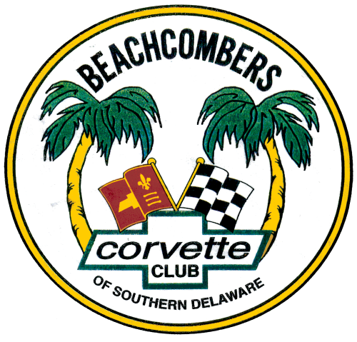

AGENDA

Tuesday July 26, 2022

5:30 p.m. – 8:00ish p.m.
Meeting called by Warren De Santis - PRESIDENT

Meeting Location:

American Legion Post 28, Millsboro, DE on Rte. 24. We will be meeting in the lower level Bingo Hall. There will be plenty of tables with seating to practice social distancing and adhere to all current Covid 19 requirements. Also, if you have chosen not to be vaccinated, please where a mask as we have several members who are immune compromised or undergoing medical treatments.

NOTE: We have arranged with the Post to have a special menu/pricing, and also have our own wait staff, so please remember to tip generously and complete the dinner order form when you arrive if you plan on eating. PLEASE EMAIL MARCY FINK PRIOR TO THE MEETING AT: marcy.fink@icloud.com SO WE CAN INCLUDE YOU IN THE HEADCOUNT FOR DINING.

NEW IMPORTANT NOTE: You may now enjoy an alcoholic beverage again in the Bingo Hall as the Post has revised their decision on past restrictions. Also you may request from our hostess your desired beverage, as Ashley is able to serve us in the Bingo Hall along with your food order.

_______________________________________________________
7:00 Lower Level - Meeting called to Order:
- Sergeant at Arms brings the room to order – Michael Jett
- Pledge of Alliance- Membership
_________________________________________________________________

7:10 Presidents Update – Warren De Santis

7:15 Asks for Reports:
Secretary’s Minutes Linda O’Sullivan
Treasurer’s Reports Terry Britland
Public Relations Cindy Carlisle
Vice President Membership Hank Selke
Museum Ambassador - Ed Simpson
________________________________________________________________

Committee Reports:
- Website Update Dennis Smith
- Facebook Update John/Linda Swidrak
- Scholarship Report Viki De Santis
- Annual Car Show Suzanne Middleton & Viki De Santis
_______________________________________________________________________

Reports of Thank You’s, Glad Tidings, Sickness or Distress: Marcy Fink – The Members Helping Members call list is up and running to assist members who require assistance in running errands and rides to doctor’s appointments, etc. if you want to be added to the list, contact : marcy.fink@icloud.com _________________________________________________________________

BIRTHDAY LIST (The “39” Again Club)

Bill Middleton – 3 Suzanne Middleton – 8 Susan Burton – 8

Bernice Carl – 9 Terry Britland – 11 Matthew Wiherle – 15

Tom Brinker – 21 Nancy Jewell – 21 Mary Catherine Hudson -22

John Swidrak – 22 Michael Zulinski - 29

OOPS, If your name is not on the list, please let us know!
_________________________________________________________

Ongoing Club Business:

Quartermaster – Club Logo-wear: LogoMotive in Rehoboth - Dennis Smith

20th Anniversary Logo and Apparel – Logo Motive in Rehoboth can print or embroider the Beachcombers official logos and the 20th Anniversary Logo on anything you bring to them for a modest cost, so consider a hat or sweatshirt if you desire sporting the clubs logo. They also provide shirts and apparel for purchase.

Club Sponsor: First State Chevrolet in Georgetown – Members now continue to receive 10% discount on service work (excluding oil changes and tires) You must show your membership card to the service desk advisors prior to the service being written up and performed to receive the discount.

Name Tags: Arthur Fink – Anyone wishing to have a name tag, please contact Arthur Fink. Due to production set-ups, orders will be placed when Arthur has several requests and can place one order for several name tags. Cost per tag is $10.

Anything “Corvette” For Sale

Floor Open for Discussions

_________________________________________________________________

New Business:

Club Challenge Coin – $15 each - Ed Marcelle

Club Annual Membership Dues –

Remain at $15 per person for 2022/23 membership- payable by May 30th -
Warren De Santis & Terry Britland

PLEASE NOTE: We have reached our 60 day grace period for paying your dues which has ended on June 30. If you have not paid your dues, your membership has automatically lapsed and your will be removed from the next updated membership roster. Re-entry into the Beachcombers will require submission new application for approval.

Club Activities: Completed, Ongoing and Scheduled

- Ongoing: Breakfasts, Lunch Runs Pop Up Outings & Member Suggestions – Membership

- Ongoing: Cruise-ins at Sydney’s in Milton every Wednesday 5:00 to 8:00pm – Ed Marcelle

- Ongoing : Coffee and Cars at the Beanery in OC , Every Sunday 9am - noon – Ed Simpson

- Completed : Cruise to St. Michaels for lunch and Classic Car Museum July 14 – Ed Marcelle

- Completed: Georgetown Speedway –July 22 - Night of Racing – Art Fink

- Scheduled – Shore Birds Ball Game & Saturday Night Fireworks – Aug 13 – Ed Marcelle

- Scheduled – Beachcombers Corvette Club Annual Charity Car Show – Aug 20 - Membership

- Scheduled – Beachcombers Fall Post 28 cruise-in – Tuesday September 20 – Warren

- Scheduled – First State Corvette Club Car Show – September 24 – Norm Kiaunis

- In Consideration – Fall Cruise in show at Salted Vines Winery – Jim Carr

- In Planning – N. Carolina Road Trip to Rick Hendriks Performance Museum in Fall – Ed Marcelle

Open for discussion for activity ideas and suggestions

_______________________________________________________

Door Prize 50/50 Adjournment

